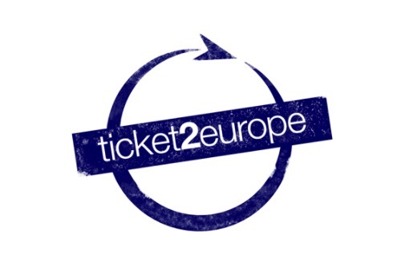
APPLICATION FORM
“Learning through Erasmus 2”
Training Course (Drobeta Turnu Severin, Romania)
21st-27th November 2017

Participant Information
First Name  [as on your passport or ID] |  |  | Family Name  [as on your passport or ID]
Nationality |  | Age: |  | Gender
Complete home address
Postal code |  | Town |  | Country
Place of Birth [ town, Country] |  | Date of Birth [DD/MM/YYYY]:
Phone (preferably mobile)  [with full international dial codes] |  |  | Fax  [with full international dial codes]
Email |  |  | Website
Passport Number [or identity card] |  |  | National ID code and Country

Sending Organization
Name | Ticket2Europe
Complete address | Novás, 3. Vilaboa
Postal code | 36141 |  | Town | Pontevedra | Country | Spain
Phone  [with full international dial codes] | +34667884753 |  |  | Fax  [with full international dial codes] | N/A
Email | romy.solomon@ticket2europe.eu |  |  | Website | www.ticket2europe.eu
Participation fee (non-members):  Participation fee (members): |  | 50 euros  0 euros
Person to Contact in Case of Emergency
Name
Complete address
Postal code |  | Town |  | Country
Phone  [with full international dial codes] |  |  | Fax  [with full international dial codes]
Email
Relationship

English level
 | Listening | Speaking | Reading | Writing
English

Health information
Please send us all relevant information concerning your health or any special needs or requirements (allergies, intolerances, mobility, medical needs, allergies, dietary restrictions, smoker/non-smoker , etc …)

____________________________________________________________________________________________________________________________________________________________________________________________________________________________________________________________________________________________________________________________________

Knowledge and experiences

- Do you have any personal experience with European Youth projects and Youth mobility programmes?
- What are your previous international experiences?

- Please describe briefly your understanding of the topic of the project?

Motivation and Expectations

- What’s your motivation in participating in this project?
- What would you like to learn, understand and experience during this training course?

- What contributions you think you can you bring for the training course?

- I hereby declare that I have carefully had entirely read and understood the Project Description.
- I hereby commit myself to participate in the whole process of this project.
- I am aware that obtaining a health and a full travel insurance are my own responsibility and at my own expense. I understand that the information I have provided on my special needs does not remove my own personal responsibility for ensuring my own health.
- I hereby declare that everything stated in the present form corresponds to the truth.

